TASK 1 : Running Python Script and various expressions in an interactive interpreter
CO1 – K3
1. Task 1: Running Python Script and various expressions in an interactive interpreter
Program 1:
Develop a program which prompts the user to input principle, rate and time and calculate compound interest. The formula is : CI = P(1+R/100)^T - P.
Program:
P = float(input("Enter the Principal amount: "))
R = float(input("Enter the Rate of interest: "))
T = float(input("Enter the Time (in years): "))
CI = P * (1 + R / 100) ** T - P
print("The Compound Interest is:", CI)

output:
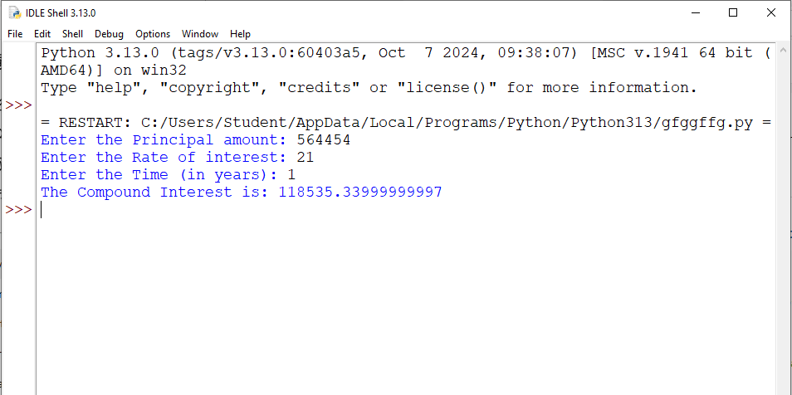

Program 2:
According to a recent survey, Biryani is the most ordered food. Chef wants to learn how to make world-class Biryani from a MasterChef. Chef will be required to attend the MasterChef's classes for X weeks, and the cost of classes per week is Y coins. What is the total amount of money that Chef will have to pay?
Program:

X = int(input("Enter the number of weeks: "))
Y = int(input("Enter the cost per week (in coins): "))
total_amount = X * Y
print("The total amount Chef has to pay is:", total_amount, "coins")

Program 3:
Create a program that reads the radius of a farmer’s field from the user in feet. Display the area of the field in acres.
Program:
radius_feet = float(input("Enter the radius of the field (in feet): "))
area_sqft = 3.14159 * radius_feet ** 2
area_acres = area_sqft / 43560
print("The area of the field is:", area_acres, "acres")

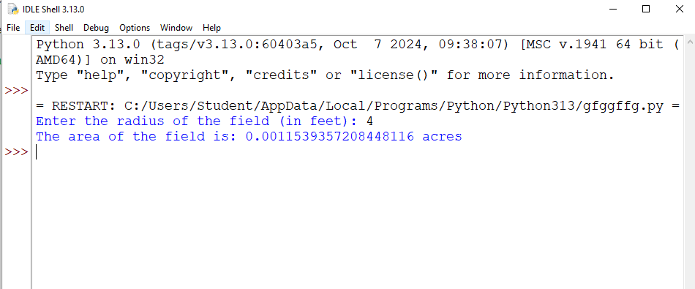
Program 4:
Two friends Ram and Sita are standing in a distance ‘d’ apart (Let’s take it as X and Y respectively) in a surface. How to find the distance between them?
Note : Formula to find the distance b/w two point:
Program:
x1 = float(input("Enter Ram's X coordinate: "))
y1 = float(input("Enter Ram's Y coordinate: "))
x2 = float(input("Enter Sita's X coordinate: "))
y2 = float(input("Enter Sita's Y coordinate: "))
distance = ((x2 - x1)**2 + (y2 - y1)**2) ** 0.5
print("The distance between Ram and Sita is:", distance)

